The Clean Divorce
Rewrite the divorce narrative embracing technology

Requirement Document

Team Members:
Course: CSIS 3375 | Section: 001
Full Name | Student Number
Atapattu, Upul M [Team Lead] | 300392188
Arachchi Mudiyanselage, Vidarshan | 300392818

Table of Contents
1. Requirements Gathering 3
1.1. Objectives for Requirements Gathering User Study 3
1.2. Choice of User Study and User Sample 3
2. Questionnaire 4
3. Data Analysis 9
Respondent Distributions 9
Visualisations based on User Needs and Behaviours 11
4. User Personas 16
4.1. Persona 1: “Overwhelmed, but wants to steer through” 16
4.2. Persona 2: “Empowered and Ready ” 17
4.3. Persona 3: “The Anxious Navigator” 19
4.4. Persona 4: “Guided, but in private.” 20
5. Requirements Generation (Designer Analysis) 22
6. Project Requirements & Priority 24
High Priority (Must-Haves) 24
Medium Priority (Should-Haves) 24
Low Priority (Could-Haves / Nice-to-Haves) 24
7. AI Usage 25
8. Work Logs 26

Requirements Gathering

Objectives for Requirements Gathering User Study
The main objectives were as follows:
- Identify what motivates the user behaviour and emotional needs that lead individuals to seek support during separation or divorce, and what they hope to achieve.
- To understand and uncover pain points that the users face, both emotionally and practically.
- To determine which specific app features are most valued by the users for the proposed CleanDivorce.
- Understand the emotional and practical needs to cope-up with the transition and practical tools required.
- Get some sense on user comfortability on using technology and privacy expectations

Choice of User Study and User Sample
Method | We have used MS Office forms for an online survey (using a structured questionnaire).
Target Users | The survey was sent to the Individuals who are contemplating, currently undergoing, or have recently completed a separation or divorce. Since this is a Riipen project, we have taken the company support to collect responses which are relevant for the context.
Sample Size | 11 total participants completed the survey.
Rationale | The proposed app is designed to support users through the entire divorce journey, (pre and post). Therefore, we sought input from users at different stages to understand the user requirements.

Questionnaire
Our team conducted a user study (survey) to better understand the needs, preferences, and behaviours of potential CleanDivorce users. The questionnaire for the survey is as follows:
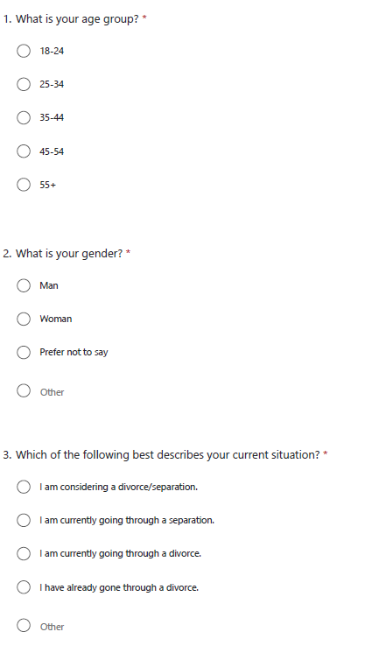

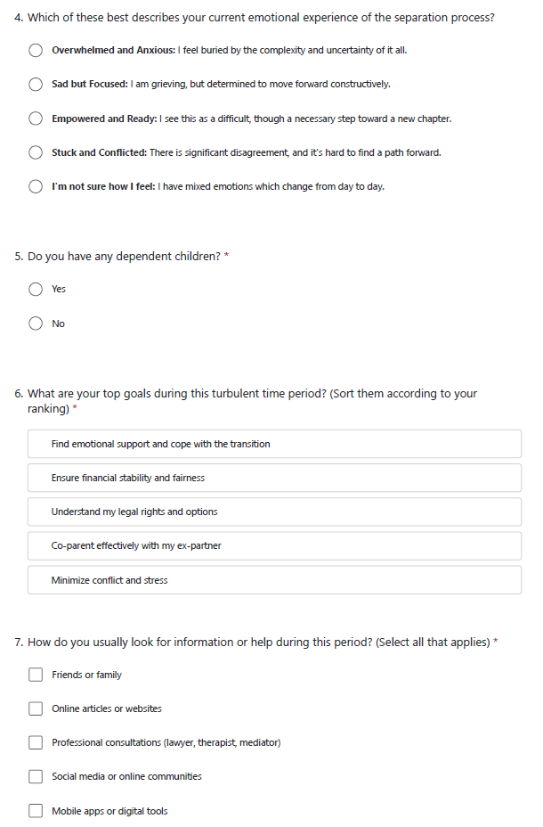
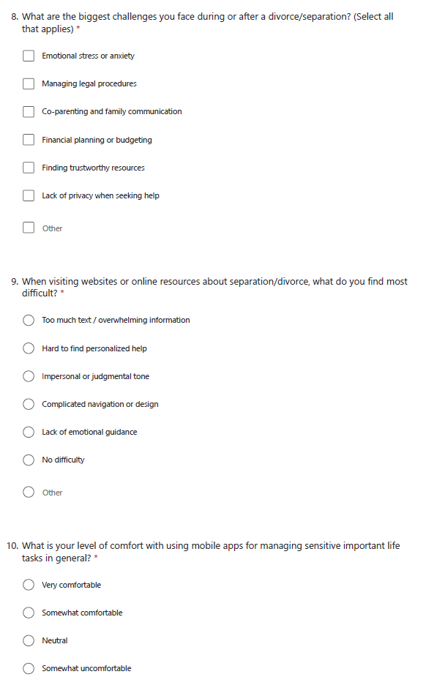
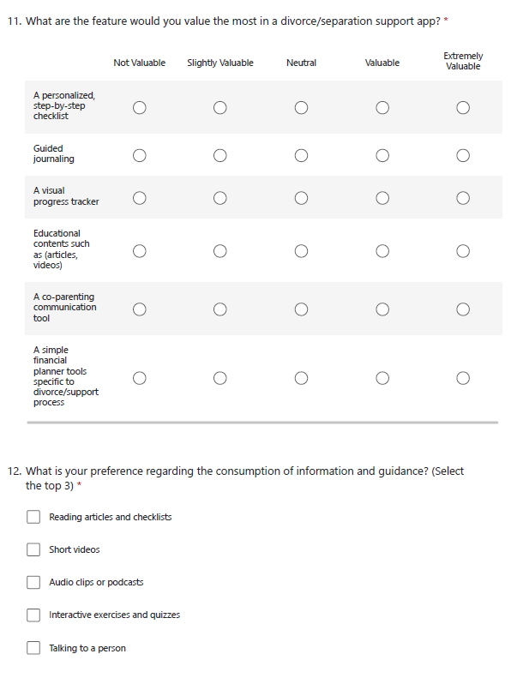

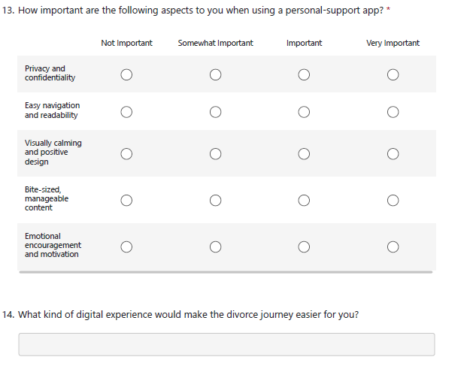

Data Analysis
From the 11 participants, we highlight a few summarized findings:

Respondent Distributions
Based on Age

Based on Gender

Based on Situation

Based on Having Dependent Children

Visualisations based on User Needs and Behaviours
The respondents current emotional experience of the separation process is as follows:
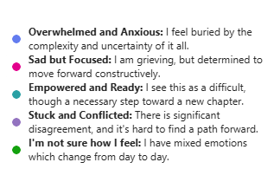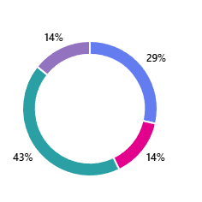

Majority of the respondents given their response as “Empowered and Ready”. This was followed by the “Overwhelmed and Anxious Goal.
We asked the users to rank their top goals during this turbulent time. The following was the ranking results of that question.
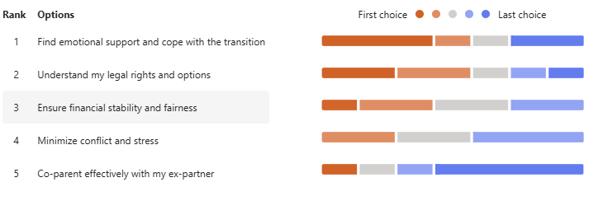
Many people prioritise finding emotional support during this transition is their top priority, followed by understanding their legal rights and options.

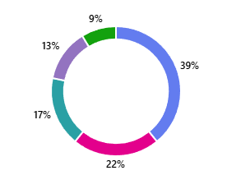
When asked about the how do they look for information or help during the period, the respondents have the given the following feedback.
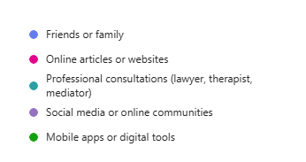

Majority of the respondents have suggested they are seeking help from family and friends. However, they also listed down that they seek support of online articles and website over professional consultations. This may be useful insight specially to understand how users approach a problem such as separation or when considering user onboarding strategy.

They have listed down their challenges during their turbulent period as follows:
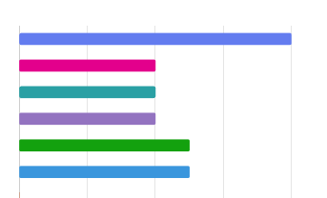
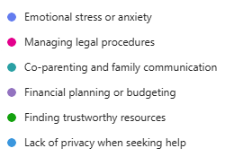

The emotional stress and anxiety were considered the most challenging item that was faced by the respondents. Since CleanDivorce is providing major support in this area, the proposed app could help out individuals to steer through these difficult times.

When asked on the level of comfort with using mobile apps for managing sensitive and important life tasks in general, nearly 90% of the respondents responded either they are neutral or comfortable. This could be a promising start for the proposed app.
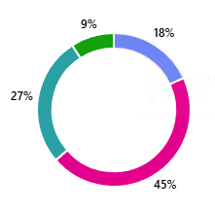
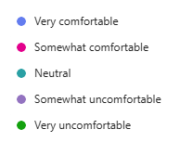

The respondents provide the following for the most valued features in a divorce/separation support app.
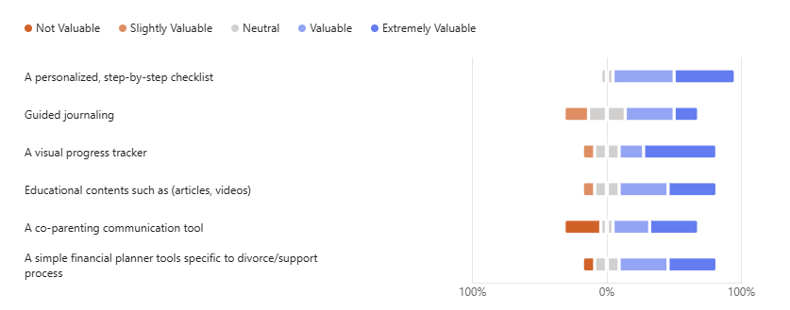
This directly provide insights on feature generation adding customer value.

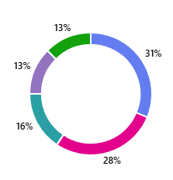
User preference regarding the consumption of information and guidance was as follows:
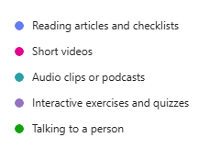

The insights in here can be useful to finetune the way the app and content is delivered. Most of the people prefered reading articles and checklists, which was closed followed by the preference for short videos.

When asked about the importance of different aspects for a personal-support app, over 90% of the respondents reponded that all the aspects listed here as important.
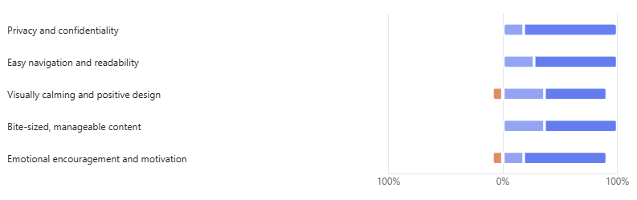

Finally, we have asked about the digital experience that the users expect which would make their life easier during their divorce journey. This was an open-ended question, and we got the following responses.
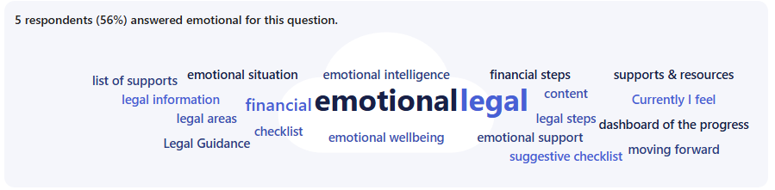
The top 3 areas were “Emotional”, “Legal” and “Financial”.

Based on the demographic profile and the behaviour of respondents, we have clustered our responses, before preparing the user personas in the next section. All these user personas are mainly derived based on the data that we collected.

User Personas

Persona 1: “Overwhelmed, but wants to steer through”
Alias: Mark
Age: 35
Gender: Man
Family Status: No Dependent Children
Current Situation: Considering a divorce/separation
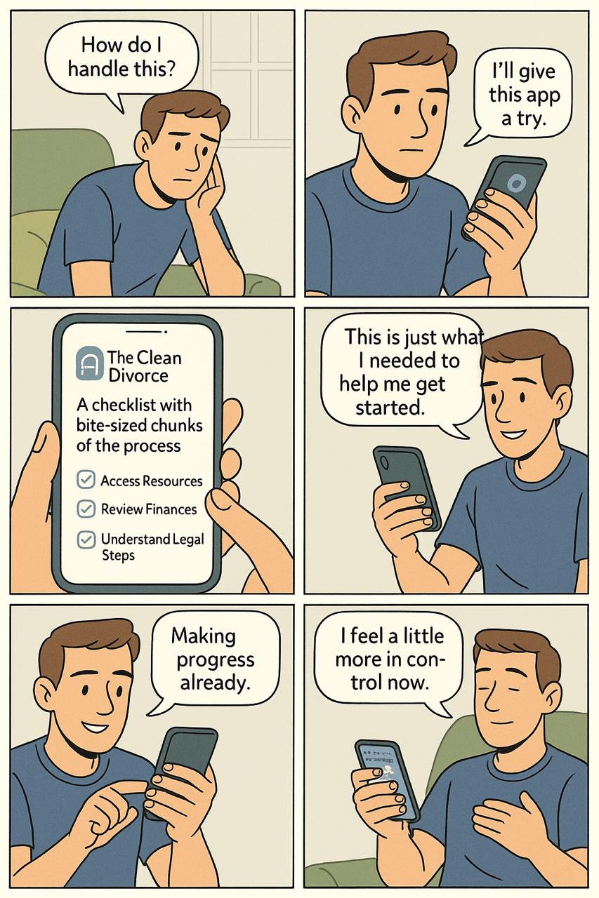
Scenario
Mark is considering divorce/separation as his relationship with his wife is struggling. He is facing internal conflict, feeling overwhelmed by the gravity of the decision he no longer has the comfort of his planned life ahead with his wife. He is anxious about whether he is making the right decision. He is worried about how to face the changes, finances, legal battles, etc.
His motivation is to get some sense of control and manage the uncertainty that he is facing. Since the uncertainty is overwhelming, he need support to start so he can steer through this. He seeks this support from his friends as well as online resources.
His Top Goals
Ensure financial stability and fairness
Understand his legal rights and options
Find emotional support and cope with the transition
Primary Challenges and Pain Points that Mark Faces
Emotional stress and anxiety
Financial planning and budgeting
Finding trustworthy resources
Privacy Concerns
Behaviour & Context
Mark is Xennial (Older Millennial) and he is comfortable with using mobile apps and researching on the web. However, the vast number of articles and content is adding to his anxiety. Finding answers to steer through uncertainty seems far away as his go to method is overloading his brain. Moreover, so many content but, it also feels impersonal.
Expectations from a Digital Tool
He values a personalized, step-by-step checklist and a visual progress tracker/dashboard because they may provide the structure that currently lacks. He need support from an emotional point of view, but he also needs to be aware of the legal process so he can plan to mitigate his concerns about the financial stability of his separation/divorce.
Interface wise, he prefers a calm, private and easy navigation interface for a digital tool. He prefers content as bite size chunks of short videos, articles to give the information that he requires.

Persona 2: “Empowered and Ready ”
Alias: Eleanor
Age: 55
Gender: Woman
Family Status: Has Dependent Children
Current Situation: Has already gone through a divorce.

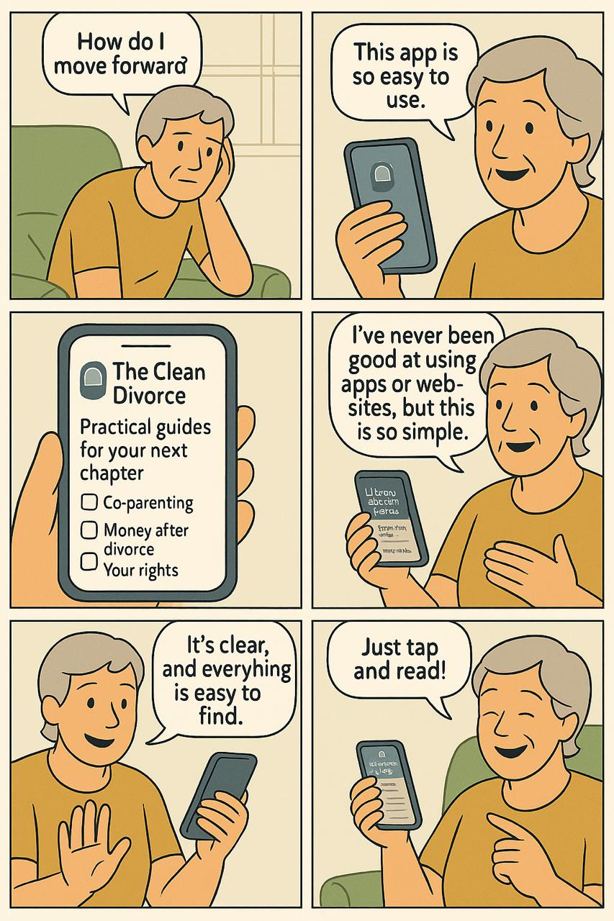
Scenario
Eleanor already has finalised her divorce sometime back ago. She feels empowered and has wants to build a good foundation for a new chapter in life. She is adjusting for her life after the divorce, and her focus is on fine-tuning her long-term financial plan to ensure her financial stability and managing a co-parenting schedule with her ex-partner. She sometimes feels stressed ensuring all the legal and financial agreements are being maintained. Her motivation is to build a secure, independent, and happy future for herself and her family.
Her Top Goals
Co-parent effectively with my ex-partner
Ensure financial stability and fairness in the long term
Understand my ongoing legal rights and options
Primary Challenges and Pain Points that Eleanor Faces
Lack of emotional guidance
Financial planning and budgeting for the future
Finding straightforward, trustworthy legal and financial information
Complicated navigation or design

Behaviour & Context
Eleanor is a Baby Boomer who is somewhat comfortable with technology. She seeks information from friends and professionals like lawyers. However, she also like to do her own research to be more diligent. She gets frustrated by websites with complicated navigation, therefore, prefer clear, direct answers. She values efficiency and credibility above all.
Expectations from a Digital Tool
In Eleanour’s scenario, she finds a personalized checklist and a financial planner extremely valuable to keep her post-divorce life organized. A co-parenting communication tool is also in her priority list to simplify logistics. She values guided journaling but prioritizing practical and easy-to-navigate tools for legal and financial planning and awareness which delivers bite-sized, actionable information. (clear articles, checklists, or short videos)

Persona 3: “The Anxious Navigator”
Alias: Ashley
Age: 32
Gender: Woman
Family Status: No dependent children
Current Situation: Currently going through a separation, hoping for an annulment.
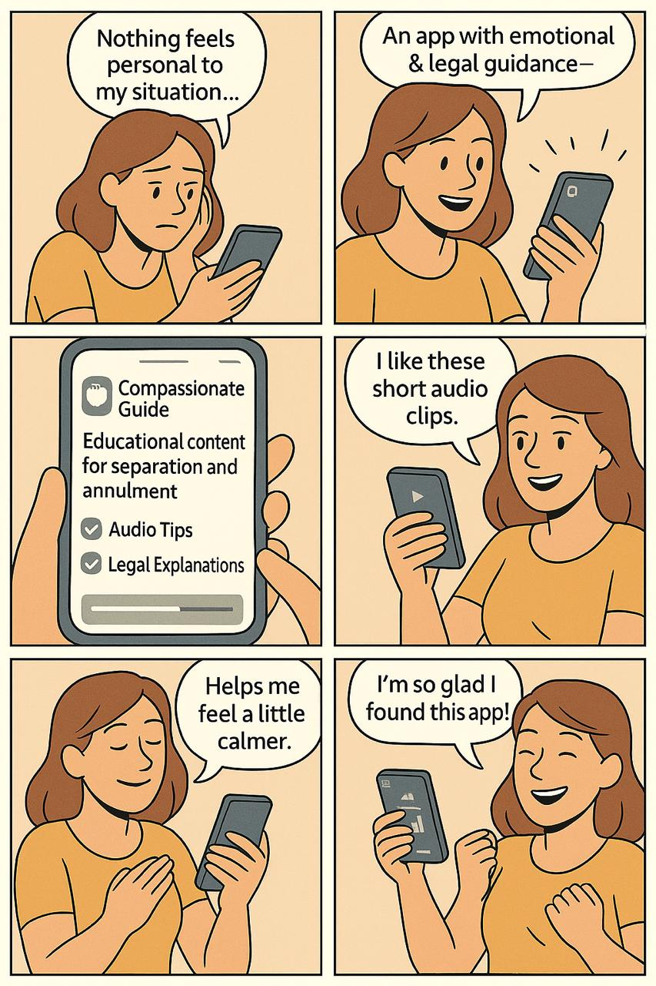
Scenario
Ashley is in the early stages of her separation. She is grieving the loss of her planned future and feels a deep sense of sadness. However, she is also determined to handle this with grace and constructiveness. Her primary focus is on understanding her unique legal standing, (specifically the possibility of an annulment). Simultaneously she is trying to manage her emotional well-being. She understands she need to balance between healing and need of understand complex legal concepts. She actively seeks information but is frustrated that she can't find resources that feel personalized or specific for her situation.
Her Top Goals
- Understand my legal rights and options
- Find emotional support and cope with the transition
- Minimize conflict and stress
Primary Challenges and Pain Points that Ashley Faces
- Finding trustworthy and relevant legal resources
- Managing emotional stress and anxiety
- Hard to find personalized help; information is too generic
Behaviour & Context
Ashley is a Millennial who is somewhat comfortable with technology. Most of the time, she turns to friends, family, and online articles for support. She gets information overload when doing her research online, as she gets lost in a sea of generic advice and cannot find clear answers to her specific questions. She is highly concerned with privacy and is cautious about what she shares online.

Expectations from a Digital Tool
She wants an app that blends emotional and practical guidance. She finds educational content "Extremely Valuable" and highly values guided journaling and a visual progress tracker to manage her anxiety and feel a sense of forward momentum. In terms of content delivery, she prefers audio clips, podcasts, and short videos, which fits her personal scenario. (and content to be bite-sized, manageable pieces). The expected app should be a private, easy to navigate one with a visually calming interface. She needs the app to act as a compassionate guide that helps to build her emotional wellbeing while building the awareness of the legal path ahead.

Persona 4: “Guided, but in private.”
Alias: Chloe
Age: 24
Gender: Woman
Family Status: No dependent children
Current Situation: Considering a divorce/separation
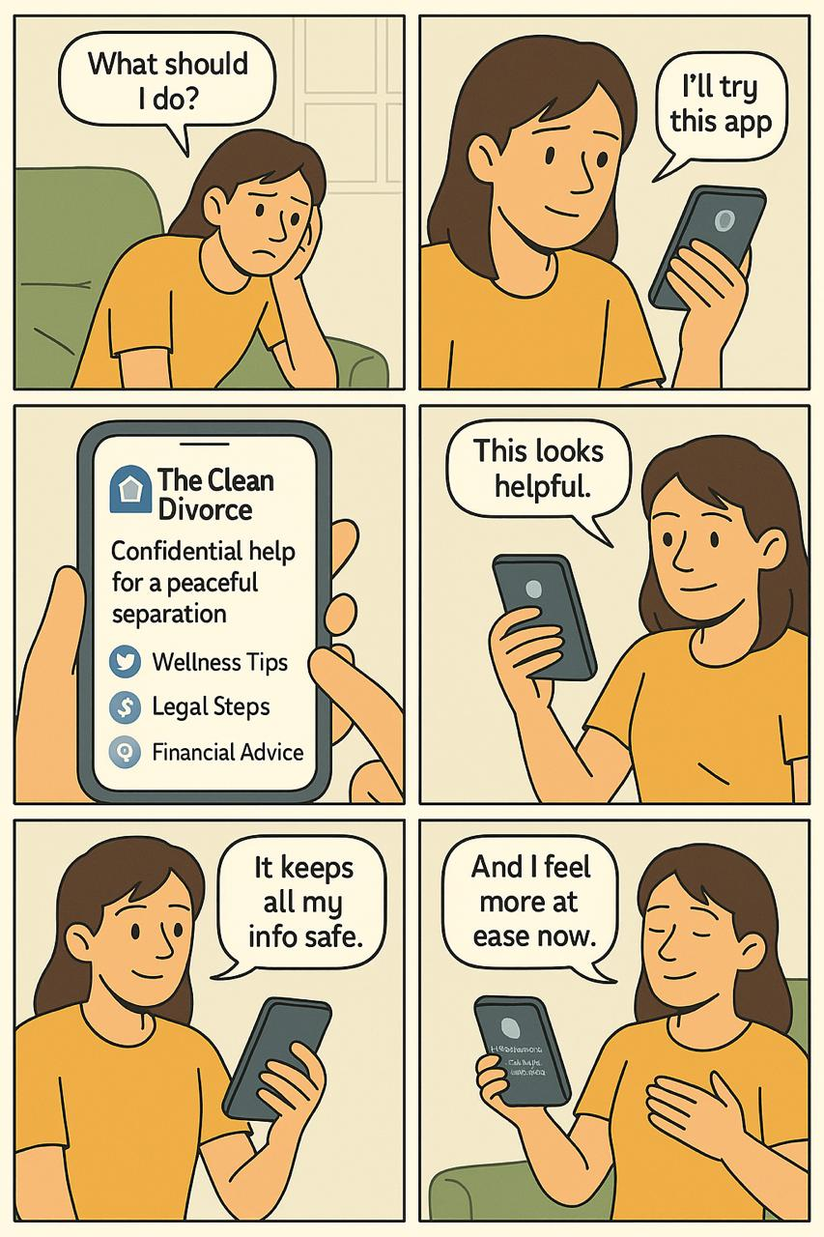
Scenario
Chloe is young lady, and she is contemplating leaving her partner. She approached professional help earlier, however, her trust in professionals has been shattered by a past therapist who took her ex-partner's side. She feels she can steer through the existing financial and legal resources and what she truly needs is guidance on how to navigate this personal crisis gracefully. She is currently navigating this almost entirely on her own as she wants to keep things to herself.
Her Top Goals
- Find emotional support and cope with the transition
- Understand my legal rights and options
- Ensure financial stability and fairness
Primary Challenges and Pain Points that Chloe Faces
- Lack of privacy when seeking help
- Emotional stress or anxiety
- Managing legal procedures
- Financial planning or budgeting Behaviour & Context
Chloe is a Gen Z digital native who is somewhat comfortable with technology but feels failed by the traditional in person help. She likes to manage and evaluate her options to divorce/separation on her own as of now and she actively seeks information online but is frustrated by resources are overly focused on the legal/financial aspects instead of the how manage her emotional wellbeing. She values privacy above all.
Expectations from a Digital Tool
She values a personalized, step-by-step checklist, guided journaling, educational content, and a visual progress tracker to provide the emotional framework and sense of direction. She like the app to be a private place with visually calming interface, easy to navigate, and full of bite-sized, emotionally intelligent content that feels trustworthy and compassionate. It must be supportive to her emotional wellbeing while helping to bring other information and planning tools to evaluate her ongoing situation.

Requirements Generation (Designer Analysis)
The following requirements were derived from our four personas (Mark, Eleanor, Ashley, and Chloe). Each requirement addresses the user needs and challenges identified during our persona analysis.
- Personal Journey and Progress Tracking
- Most of the personas valued the personal journey and progress tracking tools. Therefore, at onboarding, there could be an initial questionnaire that help to determines the user's situation, goals, and challenges to personalize their experience from the beginning.
- A visual progress tracker is need as it can shows completed steps and what's next. This may give a sense of moving forward and acknowledge the small wins which may feel rewarding.
- The personalised checklists should be matching the phase of each user and resources, and guidance should be tailored according to that. The content must cover a wide variety of emotional, financial, legal topics and should get suggested or easily accessible according to the user profile.
- Customizable Reminders can be created to allow users to set preferences for notification types (progress reminders, journaling prompts, deadline alerts) and frequency.
- Emotional Wellbeing Support
- Guided Journaling (Such as 21 Day New Beginnings Digital Journal) could be offered in structured writing exercises focused on processing emotional states and help tracking the mood. This should be provided in a form integrated to the app which can help to build the emotional readiness and self-reflection. Ensuring privacy concerns in this is extra crucial.
- Curating emotional wellbeing content library that specifically teach coping strategies, communication skills, and emotional regulation techniques.
- Legal and Financial Guidance
- Curate content on legal awareness for the users considering a separation, annulment or divorce. These can be structured in bitesize chunks. Filters may be configured based on the user's current stage or situation.
- Ensure all legal and financial information is presented in simple, accessible language with visual aids
- Organization & Planning
- Financial Planning Tools with simple calculators for asset division, support payments, and budget planning for post-divorce life. For post-divorcees, the same tools can be extended as checklist and personal planning finance planning tools.
- A secure document vault can provide safe place for important documents (financial records, legal filings, marriage certificates) with easy categorization.
- Co-parenting Support
- Create a platform for co-parenting communication with shared calendars, expense tracking, and templated messages to reduce conflict. Since most of the existing apps are addressing this, the minimal functionality threshold should be matching the competitors.
- Privacy & Accessibility
- Allow users to control what information is stored and shared with clear data protection explanations is a must.
- The users prefer information chunks in multiple formats (short videos, audio clips, articles, checklists). Therefore, the libraries of content should be compatible and accessible allowing users to access the same core information through their preferred medium.
- Feedback on the Content
- The users could rate the content so it would be suggestive for similar user profiles.
- Anonymous Community Forum
- A safe space of anonymous users to share their experience and find peer support.
By implementing these requirements, CleanDivorce could address the core needs across all user segments. The users across the board from those just considering divorce to those navigating post-divorce, can manage their life transition with privacy, trust, and emotional support.

Project Requirements & Priority
Combining insights from the survey, and the designer-driven requirements from our personas, we have created a final, prioritized list of requirements for the CleanDivorce app.

High Priority (Must-Haves)
- User onboarding must be present with an initial assessment that create customized step-by-step pathway based on the user's situation (considering, in-process, post-divorce), goals, and challenges. The user journey should be dynamic and personalised for each user’s goals.
- Integrated, private guided journaling tool must be present for emotional processing and self-reflection, crucial for building emotional readiness. This is part of the core product of the Clean Divorce website.
- Secure document vault must be available for critical financial and legal documents addressing privacy and safety concerns.
- A curated content hub is needed covering emotional, legal, and financial topics, delivered in user-selectable formats (short videos, audio clips, articles, checklists).
- A dashboard/Visual progress tracker that shows completed steps and upcoming tasks, providing a sense of accomplishment and moving forward which keep the user motivated.

Medium Priority (Should-Haves)
- Financial Planning Tools such as basic calculators for asset division, support payments, and post-divorce budgeting to reduce financial anxiety.
- Co-parenting Communication Hub: A neutral platform for shared calendars, expense tracking, and templated messages to reduce conflict for users with children.
- Customizable Notification System: Allows users to set preferences for reminders (e.g., journaling prompts, deadline alerts) to stay engaged without feeling overwhelmed.

Low Priority (Could-Haves / Nice-to-Haves)
- Content rating & suggestion system could allow the users to rate resources, enabling the app to suggest the most helpful content for similar user profiles.
- Anonymous community forum if required, however, this kind of a feature would require greater effort of moderation, and oversight to maintain safety. Furthermore, this is mainly coming from designer team idea and not backed by the user survey.

AI Usage
AI Tool | Version, Account Type | Purpose
ChatGPT | 5, Free | When I'm writing a persona for a mobile app requirement gathering, how should I structure that? I have few demographic information from the questionnaire. But, no names or personal context. Few question responses are also there, which related to the problem that he is trying to solve using the app. (Like his priorities, his emotional state, goals etc) Can I use an alias for a profile and summarise bunch of responses? What are the things that we are allowed to imagine?  https://chatgpt.com/s/t_69083a7464a08191a4f7bdd5ca264a9c
ChatGPT | 5, Free | Can we map Age groups of 18-24  25-34  35-44  45-54  55+ for different generations? Gen-Z, Millennials etc?  https://chatgpt.com/s/t_6907e619ac3881919e8dbbf58f59741d
ChatGPT | 5, Free | Can you evaluate what we have written? Persona 1: “Overwhelmed, but wants to steer through” Alias: Mark Age: 35 Gender: Man Family Status: No Dependent Children Current Situation: Considering a divorce/separation  …….  https://chatgpt.com/s/t_69083a5a8a848191bb1e801918655f69
ChatGPT | 5, Free | Can you suggest a tag line for this user persona? Persona 4: Alias: Chloe Age: 24 Gender: Woman Family Status: No dependent children Current Situation: Considering a divorce/separation Scenario…….  https://chatgpt.com/s/t_69082722e5b881918305ded3a187f25c
ChatGPT | 5, Paid | We are trying to make a divorce support, consultation and wellness app. We have done an anonymous user survey and I want to make a persona based on responses. What should I not miss when writing them?

Work Logs (Relevant for this Report)
Team Member: Upul Atapattu
Date | Hours | Description of Work Done
26-Oct- 2025 | 2 | Drafted up possible questions to include in the survey based on the guidelines and chapter content as in the requirement gathering video compiled by the instructor
28-Oct- 2025 | 1.5 | Worked with Vidarshan, the other member to check the progress on the survey before publishing it to collect user responses.
29-Oct- 2025 | 1 | Reviewed the survey again after getting feedback from the instructor. Incorporated the feedback and added an open-ended question and a draggable multiple-choice question to include participant’s perspectives in their own words and added a draggable mcq question to allow users to prioritize their requirements.
1-Nov-, 2025 | 3 | Started working on the requirements document by evaluating survey responses, establishing our idea of requirements gathering and why it is important.
2-Nov-2025 | 3 | Created the report section on survey respondents and data analysis. Created two personas (Mark and Chloe).  Review the final document.
 | 10.5

Team Member: Vidarshan Rathnayake
 | Date | Hours | Description of work done
 | 27-Oct-2025 | 2 | Setting up requirements gathering document and survey questions based on the research done so far.  Updated Riipen dashboard to the latest milestone.
 | 28-Oct-2025 | 2 | Created the Microsoft form to collect the user response as a survey, and then communicated to the other member about the progress, rectified changes and then shared it for further evaluation. Also shared the survey to initiate responses.
 | 1-Nov-2025 | 3 | Generate 2 user personas by evaluating user responses for the survey.
 | 2-Nov-2025  (Morning) | 1 | Gather and prepare the AI use section for this submission and reviewed the survey responses.
 | 2-Nov-2025  (Evening) | 2 | Generate storyboards with AI (art form) for the personas (loosely based) we wrote.  Iterated several times to make the images as clear as possible due to the weakness of AI to generate text on images.
Total |  | 10

